Ideation Phase

Brainstorm & Idea Prioritization
Date | 19 September 2026
Team ID | Shaik Irshad - 238W1A4256
Project Name | Automated Network Request Management In ServiceNow
Maximum Marks | 4 Marks

Brainstorming provided an open space for the team to generate ideas for solving the network-request problem before committing to a build. Ideas were listed without judgment, then grouped by theme, and finally prioritized on importance versus feasibility to decide what would actually be implemented in this project versus what would be left as a future enhancement.
Step 1 — Team Gathering & Problem Statement
The team agreed on a single guiding question to focus the brainstorming session, framed as a “How Might We” statement:
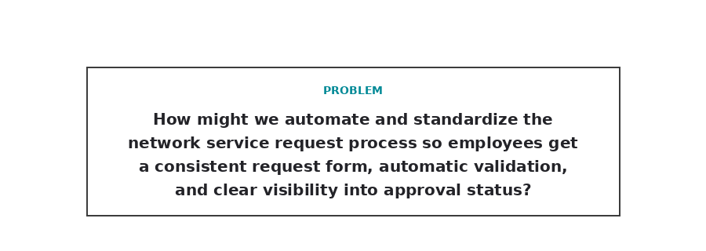
Step 2 — Brainstorm, Idea Listing & Grouping
Ideas raised during the session were written down individually and then clustered into four related themes that map directly onto the ServiceNow building blocks used later in the project: the request form and UI, the backend data model, the automation and approval mechanism, and notification/tracking.
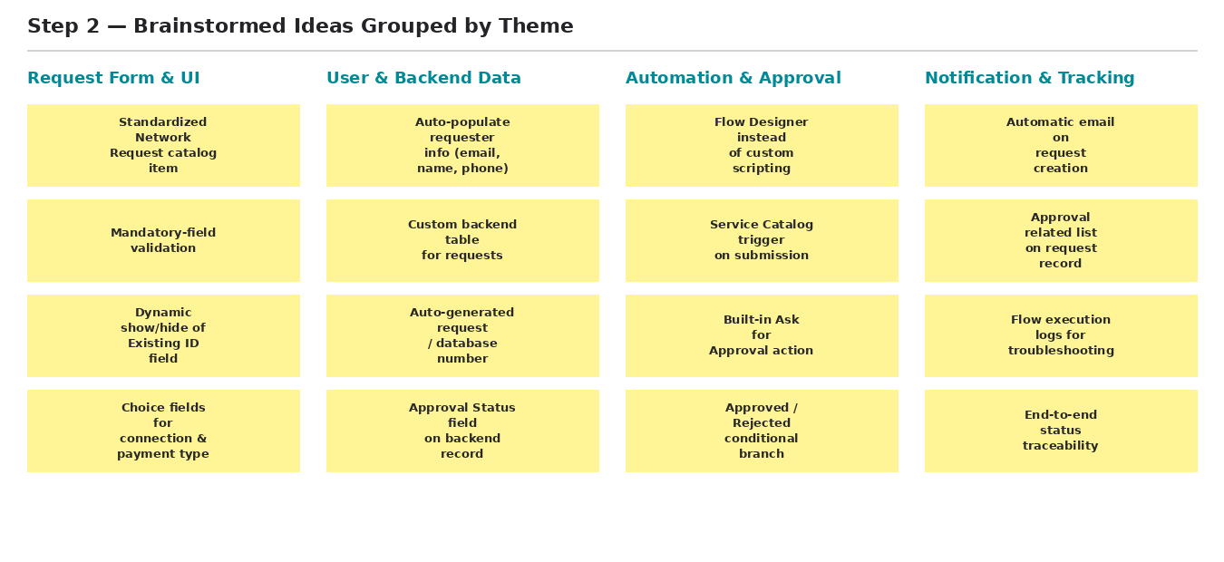
Step 3 — Idea Prioritization
Each grouped idea was then placed on an Importance vs. Feasibility grid. Ideas that were both important and feasible within the project timeline (green) were carried into the actual ServiceNow implementation. Ideas that were important but not feasible to build in this project — mainly deeper integrations — were parked as future enhancements (orange). A few low-priority ideas (grey) were consciously left out of scope.
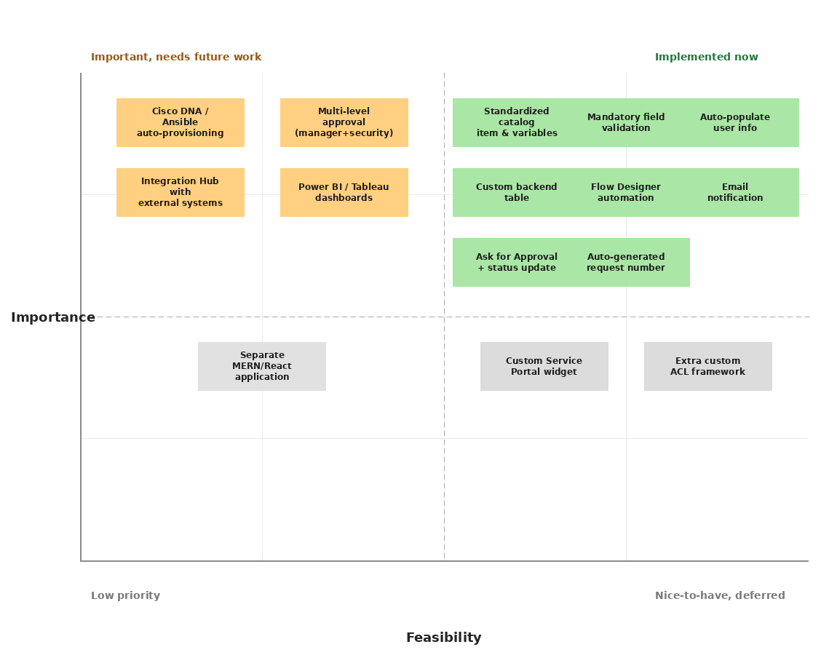
Outcome of Prioritization
The prioritization exercise directly shaped the final scope of the project:
- Implemented now: standardized catalog item and variables, mandatory-field validation, variable-set auto-population, custom backend table, Flow Designer automation, email notification, and the Ask for Approval / status-update logic.
- Deferred as future enhancements: Cisco DNA Centre / Ansible auto-provisioning, multi-level (manager + security) approval, Integration Hub connections, and Power BI / Tableau reporting dashboards.
- Left out of scope: a custom Service Portal widget, an expanded custom ACL framework, and a separate MERN/React application — the project instead relies on the standard Service Portal, default ServiceNow ACLs, and the ServiceNow platform itself.

